1150080012_Bùi Hải Đường_ CNPM_1

Lab 1

Thực hành 1

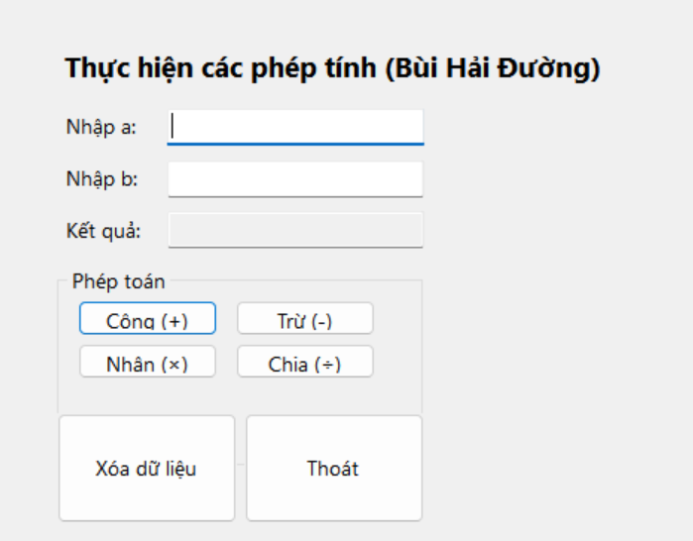

* Code xử lý xữ liệu

using System;

using System.Windows.Forms;

using static System.Windows.Forms.VisualStyles.VisualStyleElement;

namespace _1150080012_BuiHaiDuong

{

public partial class Form1 : Form

{

public Form1()

{

InitializeComponent();

}

private void label1_Click(object sender, EventArgs e)

{

}

private void label2_Click(object sender, EventArgs e)

{

}

private void button1_Click(object sender, EventArgs e)

{

try

{

double a = Convert.ToDouble(txtA.Text.Trim());

double b = Convert.ToDouble(txtB.Text.Trim());

double tong = a + b;

txtKetQua.Text = tong.ToString();

}

catch (Exception ex)

{

MessageBox.Show(ex.Message, "Thông báo lỗi!",

MessageBoxButtons.OKCancel);

}

}

private void button2_Click(object sender, EventArgs e)

{

try

{

double a = Convert.ToDouble(txtA.Text.Trim());

double b = Convert.ToDouble(txtB.Text.Trim());

double tong = a - b;

txtKetQua.Text = tong.ToString();

}

catch (Exception ex)

{

MessageBox.Show(ex.Message, "Thông báo lỗi!",

MessageBoxButtons.OKCancel);

}

}

private void button3_Click(object sender, EventArgs e)

{

try

{

double a = Convert.ToDouble(txtA.Text.Trim());

double b = Convert.ToDouble(txtB.Text.Trim());

double tong = a * b;

txtKetQua.Text = tong.ToString();

}

catch (Exception ex)

{

MessageBox.Show(ex.Message, "Thông báo lỗi!",

MessageBoxButtons.OKCancel);

}

}

private void button4_Click(object sender, EventArgs e)

{

try

{

double a = Convert.ToDouble(txtA.Text.Trim());

double b = Convert.ToDouble(txtB.Text.Trim());

double tong = a / b;

txtKetQua.Text = tong.ToString();

}

catch (Exception ex)

{

MessageBox.Show(ex.Message, "Thông báo lỗi!",

MessageBoxButtons.OKCancel);

}

}

private void button6_Click(object sender, EventArgs e)

{

DialogResult result = MessageBox.Show("Lối thoát", "Bạn có thực sự thoát hay không", MessageBoxButtons.YesNo);

if (result == DialogResult.Yes)

{

this.Close();

}

}

private void textBox1_TextChanged(object sender, EventArgs e)

{

}

private void Form1_Load(object sender, EventArgs e)

{

}

}

}

+Code design

namespace _1150080012_BuiHaiDuong

{

partial class Form1

{

/// <summary>

/// Required designer variable.

/// </summary>

private System.ComponentModel.IContainer components = null;

/// <summary>

/// Clean up any resources being used.

/// </summary>

/// <param name="disposing">true if managed resources should be disposed; otherwise, false.</param>

protected override void Dispose(bool disposing)

{

if (disposing && (components != null))

{

components.Dispose();

}

base.Dispose(disposing);

}

#region Windows Form Designer generated code

/// <summary>

/// Required method for Designer support — do not modify

/// the contents of this method with the code editor.

/// </summary>

private void InitializeComponent()

{

this.lblTitle = new System.Windows.Forms.Label();

this.lblA = new System.Windows.Forms.Label();

this.lblB = new System.Windows.Forms.Label();

this.lblKetQua = new System.Windows.Forms.Label();

this.txtA = new System.Windows.Forms.TextBox();

this.txtB = new System.Windows.Forms.TextBox();

this.txtKetQua = new System.Windows.Forms.TextBox();

this.button1 = new System.Windows.Forms.Button();

this.button2 = new System.Windows.Forms.Button();

this.button3 = new System.Windows.Forms.Button();

this.button4 = new System.Windows.Forms.Button();

this.button5 = new System.Windows.Forms.Button();

this.button6 = new System.Windows.Forms.Button();

this.grpPhepToan = new System.Windows.Forms.GroupBox();

this.grpPhepToan.SuspendLayout();

this.SuspendLayout();

//

// lblTitle

//

this.lblTitle.AutoSize = true;

this.lblTitle.Font = new System.Drawing.Font("Segoe UI", 14F, System.Drawing.FontStyle.Bold);

this.lblTitle.Location = new System.Drawing.Point(641, 105);

this.lblTitle.Margin = new System.Windows.Forms.Padding(4, 0, 4, 0);

this.lblTitle.Name = "lblTitle";

this.lblTitle.Size = new System.Drawing.Size(554, 38);

this.lblTitle.TabIndex = 0;

this.lblTitle.Text = "Thực hiện các phép tính (Bùi Hải Đường)";

this.lblTitle.Click += new System.EventHandler(this.label1_Click);

//

// lblA

//

this.lblA.AutoSize = true;

this.lblA.Font = new System.Drawing.Font("Segoe UI", 10F);

this.lblA.Location = new System.Drawing.Point(643, 171);

this.lblA.Margin = new System.Windows.Forms.Padding(4, 0, 4, 0);

this.lblA.Name = "lblA";

this.lblA.Size = new System.Drawing.Size(79, 28);

this.lblA.TabIndex = 1;

this.lblA.Text = "Nhập a:";

this.lblA.Click += new System.EventHandler(this.label2_Click);

//

// lblB

//

this.lblB.AutoSize = true;

this.lblB.Font = new System.Drawing.Font("Segoe UI", 10F);

this.lblB.Location = new System.Drawing.Point(643, 225);

this.lblB.Margin = new System.Windows.Forms.Padding(4, 0, 4, 0);

this.lblB.Name = "lblB";

this.lblB.Size = new System.Drawing.Size(81, 28);

this.lblB.TabIndex = 2;

this.lblB.Text = "Nhập b:";

//

// lblKetQua

//

this.lblKetQua.AutoSize = true;

this.lblKetQua.Font = new System.Drawing.Font("Segoe UI", 10F);

this.lblKetQua.Location = new System.Drawing.Point(643, 278);

this.lblKetQua.Margin = new System.Windows.Forms.Padding(4, 0, 4, 0);

this.lblKetQua.Name = "lblKetQua";

this.lblKetQua.Size = new System.Drawing.Size(83, 28);

this.lblKetQua.TabIndex = 3;

this.lblKetQua.Text = "Kết quả:";

//

// txtA

//

this.txtA.Font = new System.Drawing.Font("Segoe UI", 10F);

this.txtA.Location = new System.Drawing.Point(751, 167);

this.txtA.Margin = new System.Windows.Forms.Padding(4);

this.txtA.Name = "txtA";

this.txtA.Size = new System.Drawing.Size(257, 34);

this.txtA.TabIndex = 0;

this.txtA.TextChanged += new System.EventHandler(this.textBox1_TextChanged);

//

// txtB

//

this.txtB.Font = new System.Drawing.Font("Segoe UI", 10F);

this.txtB.Location = new System.Drawing.Point(751, 221);

this.txtB.Margin = new System.Windows.Forms.Padding(4);

this.txtB.Name = "txtB";

this.txtB.Size = new System.Drawing.Size(257, 34);

this.txtB.TabIndex = 1;

//

// txtKetQua

//

this.txtKetQua.Font = new System.Drawing.Font("Segoe UI", 10F);

this.txtKetQua.Location = new System.Drawing.Point(751, 274);

this.txtKetQua.Margin = new System.Windows.Forms.Padding(4);

this.txtKetQua.Name = "txtKetQua";

this.txtKetQua.ReadOnly = true;

this.txtKetQua.Size = new System.Drawing.Size(257, 34);

this.txtKetQua.TabIndex = 2;

this.txtKetQua.TabStop = false;

//

// button1

//

this.button1.Font = new System.Drawing.Font("Segoe UI", 10F);

this.button1.Location = new System.Drawing.Point(21, 35);

this.button1.Margin = new System.Windows.Forms.Padding(4);

this.button1.Name = "button1";

this.button1.Size = new System.Drawing.Size(141, 37);

this.button1.TabIndex = 0;

this.button1.Text = "Cộng (+)";

this.button1.UseVisualStyleBackColor = true;

this.button1.Click += new System.EventHandler(this.button1_Click);

//

// button2

//

this.button2.Font = new System.Drawing.Font("Segoe UI", 10F);

this.button2.Location = new System.Drawing.Point(180, 35);

this.button2.Margin = new System.Windows.Forms.Padding(4);

this.button2.Name = "button2";

this.button2.Size = new System.Drawing.Size(141, 37);

this.button2.TabIndex = 1;

this.button2.Text = "Trừ (-)";

this.button2.UseVisualStyleBackColor = true;

this.button2.Click += new System.EventHandler(this.button2_Click);

//

// button3

//

this.button3.Font = new System.Drawing.Font("Segoe UI", 10F);

this.button3.Location = new System.Drawing.Point(21, 80);

this.button3.Margin = new System.Windows.Forms.Padding(4);

this.button3.Name = "button3";

this.button3.Size = new System.Drawing.Size(141, 37);

this.button3.TabIndex = 2;

this.button3.Text = "Nhân (×)";

this.button3.UseVisualStyleBackColor = true;

this.button3.Click += new System.EventHandler(this.button3_Click);

//

// button4

//

this.button4.Font = new System.Drawing.Font("Segoe UI", 10F);

this.button4.Location = new System.Drawing.Point(180, 80);

this.button4.Margin = new System.Windows.Forms.Padding(4);

this.button4.Name = "button4";

this.button4.Size = new System.Drawing.Size(141, 37);

this.button4.TabIndex = 3;

this.button4.Text = "Chia (÷)";

this.button4.UseVisualStyleBackColor = true;

this.button4.Click += new System.EventHandler(this.button4_Click);

//

// button5

//

this.button5.Font = new System.Drawing.Font("Segoe UI", 10F);

this.button5.Location = new System.Drawing.Point(641, 483);

this.button5.Margin = new System.Windows.Forms.Padding(4);

this.button5.Name = "button5";

this.button5.Size = new System.Drawing.Size(181, 114);

this.button5.TabIndex = 4;

this.button5.Text = "Xóa dữ liệu";

this.button5.UseVisualStyleBackColor = true;

//

// button6

//

this.button6.Font = new System.Drawing.Font("Segoe UI", 10F);

this.button6.Location = new System.Drawing.Point(829, 483);

this.button6.Margin = new System.Windows.Forms.Padding(4);

this.button6.Name = "button6";

this.button6.Size = new System.Drawing.Size(181, 114);

this.button6.TabIndex = 5;

this.button6.Text = "Thoát";

this.button6.UseVisualStyleBackColor = true;

this.button6.Click += new System.EventHandler(this.button6_Click);

//

// grpPhepToan

//

this.grpPhepToan.Controls.Add(this.button1);

this.grpPhepToan.Controls.Add(this.button2);

this.grpPhepToan.Controls.Add(this.button3);

this.grpPhepToan.Controls.Add(this.button4);

this.grpPhepToan.Font = new System.Drawing.Font("Segoe UI", 10F);

this.grpPhepToan.Location = new System.Drawing.Point(641, 331);

this.grpPhepToan.Margin = new System.Windows.Forms.Padding(4);

this.grpPhepToan.Name = "grpPhepToan";

this.grpPhepToan.Padding = new System.Windows.Forms.Padding(4);

this.grpPhepToan.Size = new System.Drawing.Size(369, 207);

this.grpPhepToan.TabIndex = 3;

this.grpPhepToan.TabStop = false;

this.grpPhepToan.Text = "Phép toán";

//

// Form1

//

this.AcceptButton = this.button1;

this.AutoScaleDimensions = new System.Drawing.SizeF(9F, 20F);

this.AutoScaleMode = System.Windows.Forms.AutoScaleMode.Font;

this.ClientSize = new System.Drawing.Size(1697, 834);

this.Controls.Add(this.button6);

this.Controls.Add(this.button5);

this.Controls.Add(this.grpPhepToan);

this.Controls.Add(this.txtKetQua);

this.Controls.Add(this.txtB);

this.Controls.Add(this.txtA);

this.Controls.Add(this.lblKetQua);

this.Controls.Add(this.lblB);

this.Controls.Add(this.lblA);

this.Controls.Add(this.lblTitle);

this.FormBorderStyle = System.Windows.Forms.FormBorderStyle.FixedDialog;

this.Margin = new System.Windows.Forms.Padding(4);

this.MaximizeBox = false;

this.Name = "Form1";

this.StartPosition = System.Windows.Forms.FormStartPosition.CenterScreen;

this.Text = "Máy tính 4 phép - WinForms";

this.Load += new System.EventHandler(this.Form1_Load);

this.grpPhepToan.ResumeLayout(false);

this.ResumeLayout(false);

this.PerformLayout();

}

#endregion

private System.Windows.Forms.Label lblTitle;

private System.Windows.Forms.Label lblA;

private System.Windows.Forms.Label lblB;

private System.Windows.Forms.Label lblKetQua;

private System.Windows.Forms.TextBox txtA;

private System.Windows.Forms.TextBox txtB;

private System.Windows.Forms.TextBox txtKetQua;

private System.Windows.Forms.GroupBox grpPhepToan;

private System.Windows.Forms.Button button1; // Cộng

private System.Windows.Forms.Button button2; // Trừ

private System.Windows.Forms.Button button3; // Nhân

private System.Windows.Forms.Button button4; // Chia

private System.Windows.Forms.Button button5; // Xóa

private System.Windows.Forms.Button button6; // Thoát

}

}

Kết quả:

-Phép cộng:

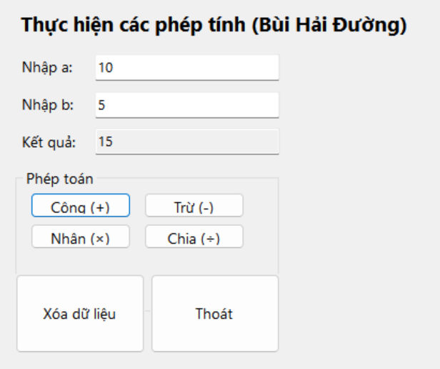

-Phép trừ:

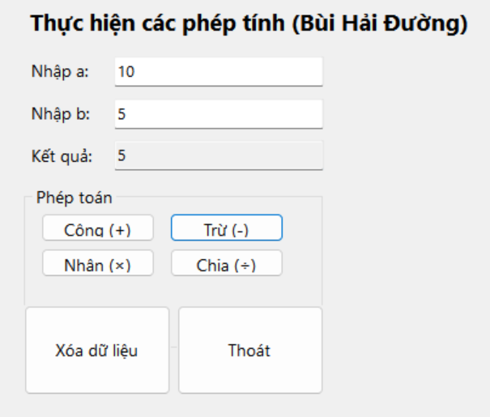

-Phép nhân:

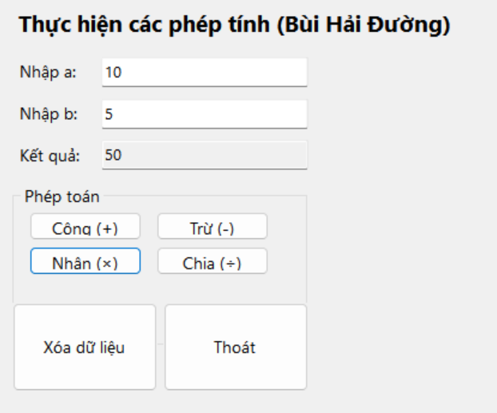

-Phép chia: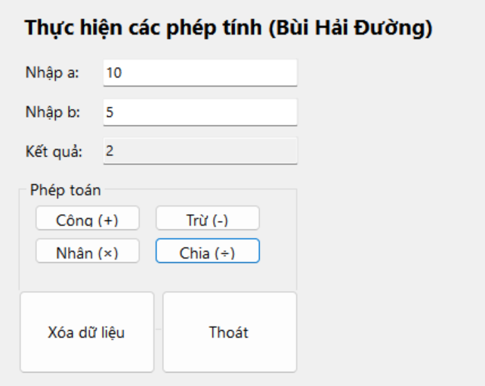

Áp dụng 1:

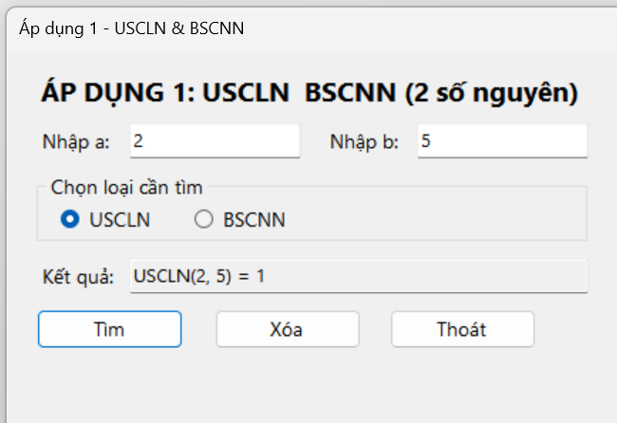

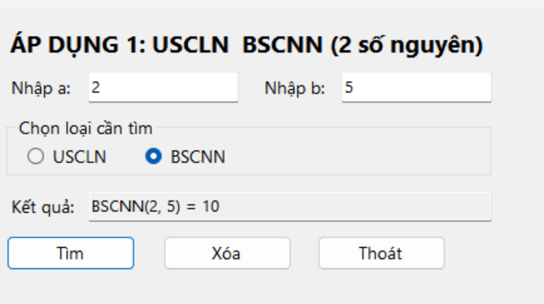

Áp dụng 2:

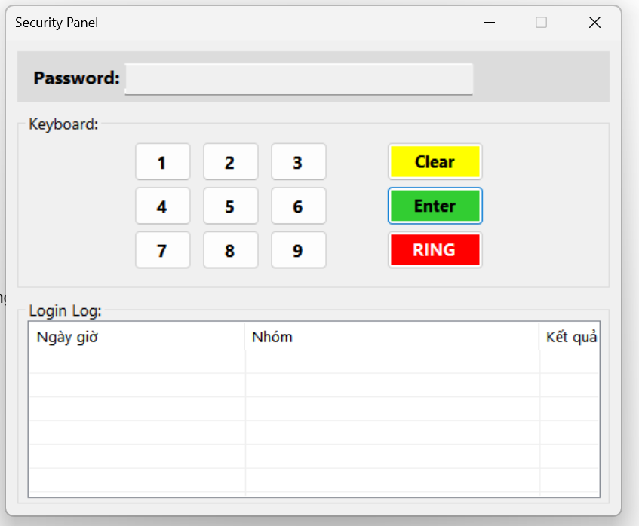

Nhập và kiểm tra

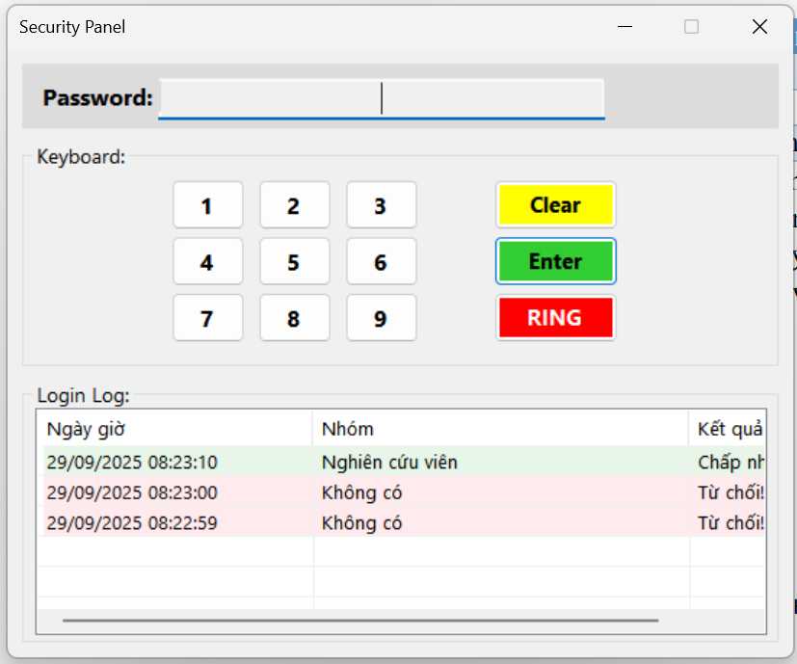

2 Thực hành 2

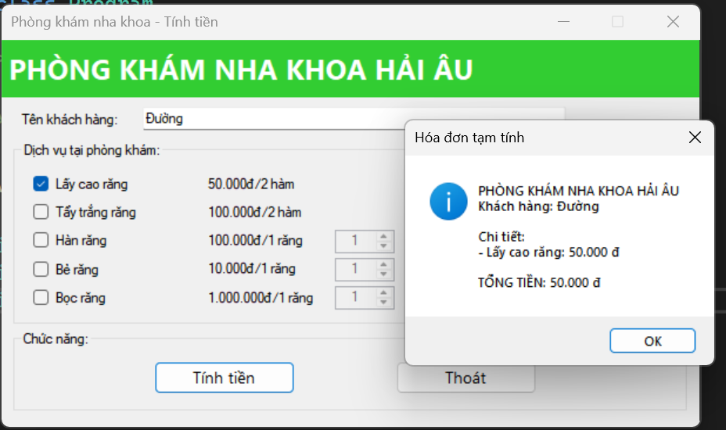

Áp dụng 3:

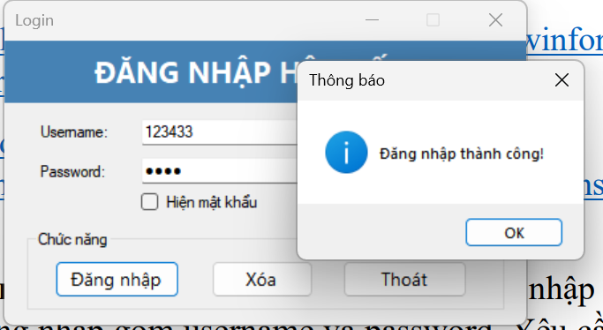

**Thực hành 3**

